**DAILY ONLINE ACTIVITIES SUMMARY**

|  |  |  |  |  |  |  |  |
| --- | --- | --- | --- | --- | --- | --- | --- |
| **Date:** | **11-06-2020** | | | | **Name:** | **B.A.SOHANKUMAR** | |
| **Sem & Sec** | **4TH SEM A** | | | | **USN:** | **4AL18CS013** | |
| **Online Test Summary** | | | | | | | |
| **Subject** | | **----** | | | | | |
| **Max. Marks** | | **----** | | **Score** | | **----** | |
| **Certification Course Summary** | | | | | | | |
| **Course** | **INTRODUCTION TO DIGITAL MARKETING** | | | | | | |
| **Certificate Provider** | | | **GLA** | **Duration** | | | **2.5 HOURS** |
| **Coding Challenges** | | | | | | | |
| **Problem Statement:1: Write a java program to segregate even and odd numbers.** | | | | | | | |
| **Status: EXECUTED** | | | | | | | |
| **Uploaded the report in Github** | | | | **YES** | | | |
| **If yes Repository name** | | | | **LOCKDOWN CODING** | | | |
| **Uploaded the report in slack** | | | | **YES** | | | |

**CERTIFICATION COURSE DETAILS:**

Course: Introduction to digital marketing

Today I have opted this new course.Totally it consists of 10 modules.Completed topics are Consumer Journey of Today,Explanation of New Medias,Explanation of New Medias -Contd,Understanding Brand Purpose,Introduction to Facebook Marketing,Purpose of using Facebook as Marketing Channel,Facebook Interface and Types of Audiences,Adset Set up guide,What is custom audience,Types of ads and taken the assessment quiz.

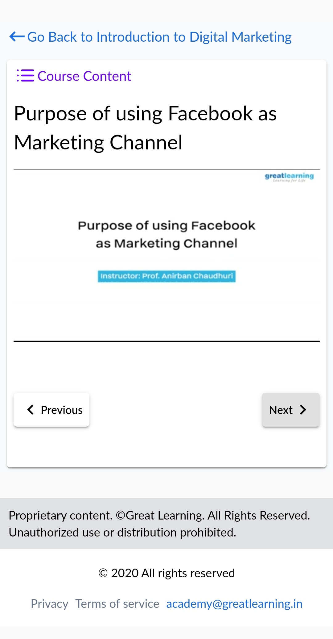 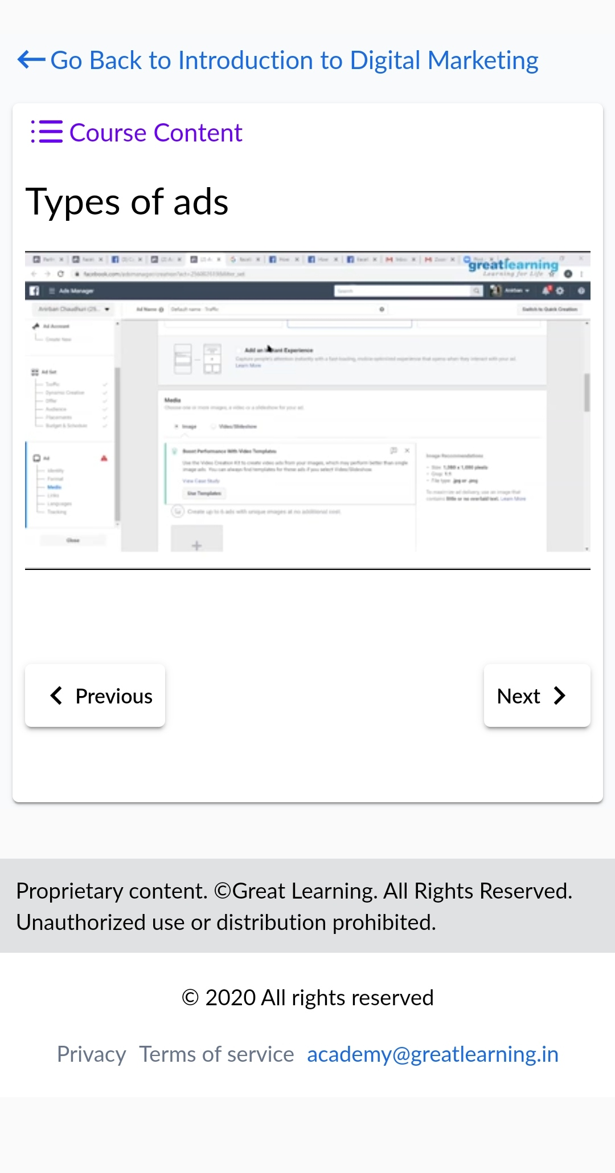

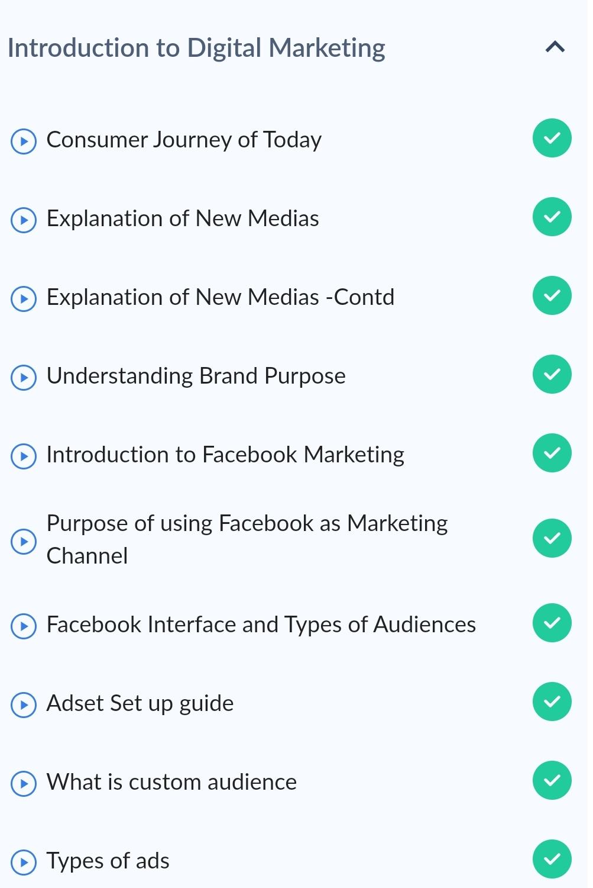completed modules

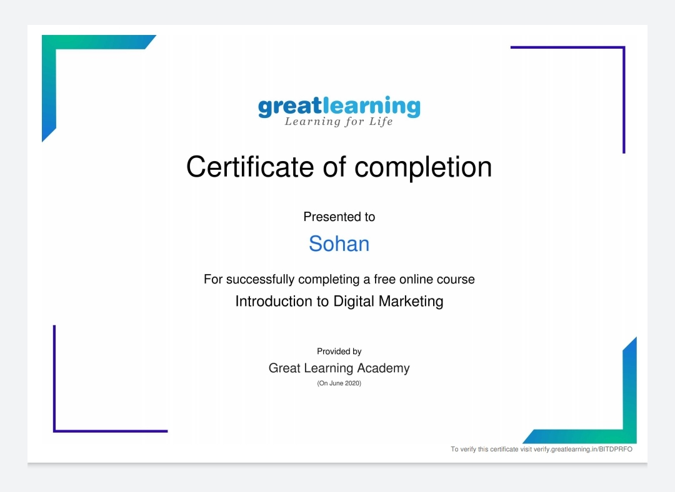

Above certificate is awarded for the completion of this course.

**CODING CHALLENGES:**

1.Write a java program to segregate even and odd numbers.Given an array A[], write a function that segregates even and odd numbers. The functions should put all even numbers first, and then odd numbers.

Example:Input = {12, 34, 45, 9, 8, 90, 3} Output = {12, 34, 8, 90, 45, 9, 3}

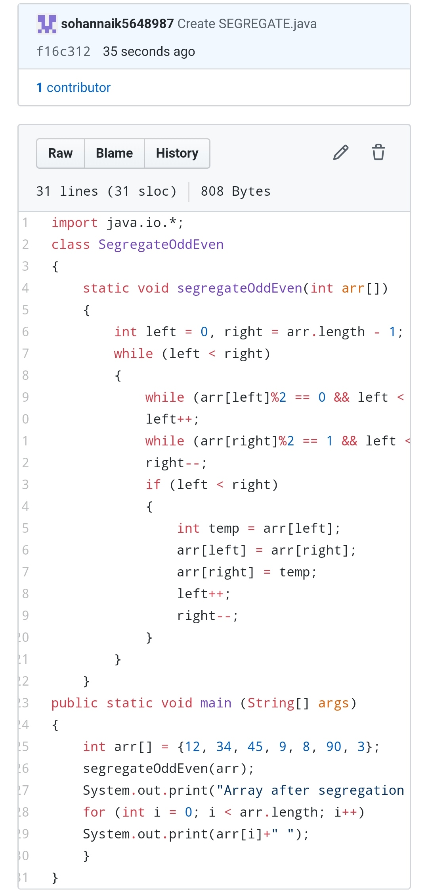

REPOSITORY LINK:https://github.com/sohannaik5648987/JAVA-CODING